Contents

Tools used. 2

Project setup 3

Project and folder structure 3

Repository and Model 5

Service and its implementation 6

Rest Controllers 7

Database setup and connection 8

Spring security 9

Running the project 10

# Tools used.

|  |  |
| --- | --- |
| **Tools** | **Description** |
| Spring tool suite | * IDE for coding the spring application. * Comes with built in spring starter project builder and spring snippet |
| Postman | * Desktop application for testing REST API |
| GitHub | * Repository for code backup, storage, and version management |
| GitHub Link | <https://github.com/bibash44/spring-boot-addressbook-API> |
| Demo Video Link | <https://youtu.be/2Zryh_cge60> |

# Project setup

* Project was built using spring starter in Spring Tool Suite IDE
* Java Version 17 was used.
* Dependencies packages like **Spring Web, Spring Data JPA, Spring Security, Lombok, H2Database** were installed.

# Project and folder structure

* Necessary packages like Model, Controller, Repository, Service, Service Implementation were created along with required files as shown below.

# Repository and Model

* Model AddressBook was created along with the required attributes.
* Getter, Setter, constructor were written (*Note: Lombok was not working*)
* Hibernate JPA annotation was used for identifying Entity and its attributes.
* Finally, repository for the Model was defined inside the repository package

# Service and its implementation

* Services were defined in a interface (Service Interface) and implemented (ServiceImpl.Java) in a service implementation class by overriding them
* CRUD operation DAO (Data Access Object) were written as service and the business logic was implemented using those DAOs as shown below
* Implemented methods CRUD operation were performed using JPA provided default ORM (Object Relation Mapping)

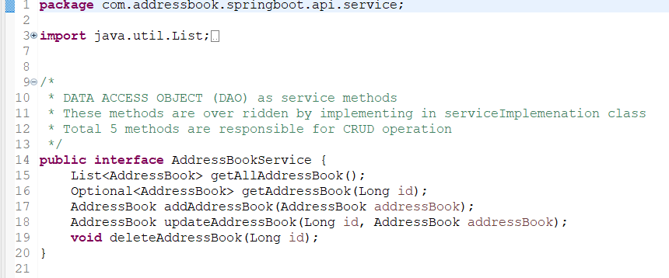

More on code …….

# Rest Controllers

* All the rest controllers and API end points were defined in controller file (AddressBookController.Java)
* Base end point was set to **/api/v1/address-book**
* GET, POST, PUT, DELETE were used for creating the API end points as shown below

More on code …….

# Database setup and connection

* H2 in-memory database was used.
* All the necessary variables and data source were defined in application.properties file for enabling database connection as shown below

# Spring security

* Spring security was configured using spring security dependency
* Security was defined for authorization and authentication.
* Authentication was defined for user by creating bean using UserDetailsService authentication service and SecurityFilterChain HTTPRequest authorization all provided by spring security
* HTTP basic authorization is used instead of form authorization.
* The defined user roles were assigned to each route in Controller routes where endpoints were created which only allows specific user to use that route.

Spring Security Configuration

Rest Controller

# Running the project

* Project can be run in the local machine.
* Download the project and import in the IDE like **VS CODE, SPRING TOOL SUITE or intellij IDE**
* Run Maven install or execute POM.XML before running the project for downloading maven and JAR files
* Finally run the project as Spring boot Web application
* Test the API using POST man or CURL